

# Mini Project Report on

# “Railway Ticket Reservation Website”

**Submitted in partial fulfilment of the requirement for award of the degree of**

# BACHELOR OF TECHNOLOGY

in

**Computer Science and Engineering (Artificial Intelligence & Machine Learning)**

## Aman Singh, 2200681530013, 3rd Sem

Abhinav Chaudhary, 2200681530006, 3rd Sem

Mahak Gupta, 2200681530056, 3rd Sem

Anushka Goyal, 2200681530017, 3rd Sem

# Under the Guidance of

Mr. Rahul Malik

**DEPARTMENT OF COMPUTER SCIENCE AND ENGINEERING**

**(AI & ML)**

## MEERUTINSTITUTEOFENGINEERING&TECHNOLOGY,

## MEERUT

AFFILIATED TO

### DR. A. P. J. ABDUL KALAM TECHNICAL UNIVERSITY, LUCKNOW



**JAN2024**

**Table of Content**

|  |  |  |
| --- | --- | --- |
| **Description** |  | Page No. |
| **Declaration** |  | 2 |
| **Certificate** |  | 3 |
| **Acknowledgement** |  | 4 |
| **Abstract** |  | 5 |
|  |  |  |
| **Chapter 1** | Introduction | 6 |
| **Chapter 2** | System Design | 7 |
| **Chapter 3** | Technology Bucket | 8 |
| **3.1** | Description of HTML |  |
| **3.2** | Description of CSS |  |
| **3.3** | Description of JavaScript |  |
| **Chapter 4** | Code | 11 |
| **Chapter 5** | Output Screen | 37 |
| **Appendices** |  | 42 |
| **References** |  | 43 |
|  |  |  |
|  |  |  |

# DECLARATION

We hereby declare that the project titled - “Railway Ticket Reservation”, which is being submitted as Mini Project in the department of Computer Science and Engineering (Artificial Intelligence & Machine Learning) to Meerut Institute of Engineering and Technology, Meerut (U.P.) is an authentic record of our genuine work done under the guidance of “Mr. Rahul Malik” of “CSE (AI&ML)”, Meerut Institute of engineering and technology.

Date: 7 December 2023

**Student name: AMAN SINGH (2200681530013)**

**ABHINAV CHAUDHARY (2200681530006)**

**ANUSHKA GOYAL(2200681530017)**

**MAHAK GUPTA (2200681530056)**

Place: MEERUT

# 

# CERTIFICATE

This is to certify that mini project report titled – “Railway Ticket Reservation” submitted by “abhinav chaudhary(2200681530006.), Aman singh (2200681530016), Anushka goyal (2200681530017) Mahak gupta (2200681530056)” has been carried out under the guidance of “Mr. Rahul Malik” of “CSE (AI&ML)”, Meerut Institute of Engineering and

Technology, Meerut. This project report is approved for Mini Project in 3rd semester in CSE (AI&ML) from Meerut Institute of Engineering and Technology, Meerut.

SUPERVISOR: Mr Rahul Malik

Date: 7 December 2023

.

# 

# ACKNOWLEDGEMENT

We express our sincere gratitude towards our guide “Mr. Rahul Malik” of “CSE (AI&ML)”, Meerut Institute of Engineering and Technology, Meerut for his valuable suggestion, guidance and supervision throughout the project work. We would also like to thank our Head of Department “Dr. Rambir Singh” of “CSE (AI/AI&ML)” for his expert advice from time to time. We owe sincere thanks to all the faculty members of our department for their kind encouragement.

Date: 07 December 2023

**AMAN SINGH (2200681530013)**

**ABHINAV CHAUDHARY (2200681530006)**

**ANUSHKA GOEL (2200681530017)**

**MAHAK GUPTA (2200681530056)**

**Abstract**

**\*\*Project Title:** Railway Ticket Reservation System**

**\*\*Objective:\*\***

**The Railway Ticket Reservation System is designed to automate the process of booking train tickets, making it convenient and efficient for both passengers and railway staff. The primary goal is to create a user-friendly platform that allows passengers to check train schedules, reserve seats, and purchase tickets seamlessly.**

**\*\*Benefits:\*\***

**- **Convenience:** Users can book tickets from the comfort of their homes.**

**- **Time-Saving:** Eliminates the need for physical ticket counters and long queues.**

**- **Accuracy:** Real-time updates ensure accurate seat availability information.**

**- **Efficiency:** Streamlines the ticketing process for both passengers and railway authorities.**

**\*\*Challenges:\*\***

**- **Technical Challenges:** Integration with payment gateways and ensuring system scalability.**

**- **Security Concerns:** Protecting user data and ensuring secure transactions.**

**- **User Education:** Ensuring users are familiar with the online reservation system.**

**Chapter**_**1**

**Introduction**

The website is on the topic - ‘RAILWAY RESERVATION’. The website name is “RAILWAY TICKET RESERVATION WEBSITE”, the reservation website that provides travel ticket details, home page, meals of trains, holiday bookings, sitting plans, and other customer support.

1. HOME

Clicking on ‘Home’ option you are able to see the home page of the website which Contains other options as well. There is also information about the content of the website.

You can visit the content of the site by clicking on the connected links.

1. MEALS

In this section you can see the information related to the meals that a specific trains offers.

1. HOLIDAY PACKAGES

In this section you will see our packages. The recent deals that we made and the recents Destination that we decide for travelling.

1. SERVICE

Service sections conations specific services which a trains offers a different types of persons.

1. CONTACT US

Contact us page contains a form. The form can be filled by those who have any query related to the places for travelling.

.

**CHAPTER->2**

### SYSTEM DESIGN

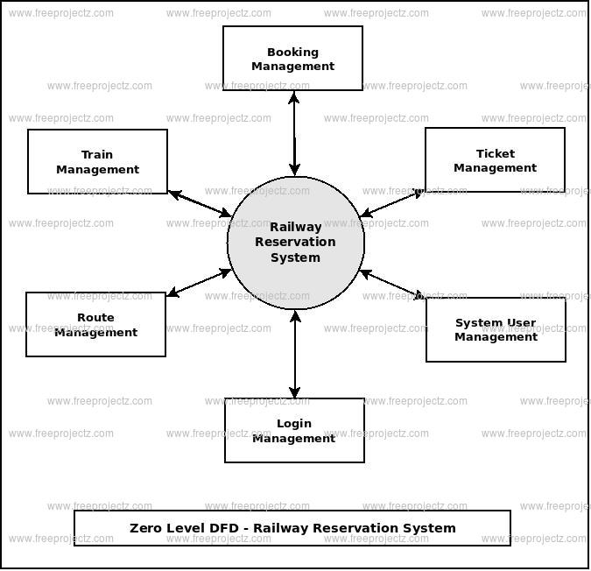

### CHAPTER­_3 TECHNOLOGY BUCKET

#### 3.1) HTML

Hyper Text Markup Language (HTML) is a type of markup language It is used to Make webpages. Webpages can include writing, links, pictures, and even sound and video. HTML tells web browsers what webpages should look like. HTML also adds meta information to webpages. Meta information is information about a webpage e.g., the name of the person who created the page.

Web browsers usually do not show meta information.

HTML is often used with cascading style sheet (CSS) and java script. CSS is used to change the way HTML looks. JavaScript tells websites how to behave. It can also change HTML and CSS.

* The <! DOCTYPE html> declaration defines this document to be HTML.
* The < html> tag encloses the complete html file and contains the header i.e. <head>….

</head> tag and the body tag i.e.

<body>…. </body>.

* The <head> tag contains the header of the file and also contains the <title>… </title> tag and the <style>... </style> tag of CSS.
* The <title> tag contains the title of the html file which shows in the header of the browser.
* The <body> tag contains all the contents of an html document such as headings, paragraphs, images, hyperlinks, tables, lists etc. F) The <h1> tag in html indicates a heading on a website. Html has six different heading tags – h1, h2, h3, h4, h5, h6.
* The <div> tag in html defines a division or a section in an html document.
* The <form> tag is used to create an html form for user input. I) The <input> tag is used to create interactive controls for web-based forms in order to accept data from the user.
* J) The <button> tag is used to create a clickable button within html form on your webpage

**3.2) CSS**:

* The CSS stands for Cascading Style Sheets and it is used for describing the presentation of a document written in a markup language like html.
* The background-image property is used for set the image in the background. Syntax: body

{background-image: URL (‘file name’);}

* In the CSS, a class selector is a name preceded by a full stop (“.”) and an ID selector is a name preceded by a hash character (“#”).
* ID is used to identify one element and class is used to identify more than one element. • Margin and padding are the two most commonly used properties for spacing out elements. Margin is the space outside something and padding is the space inside something.
* The: hover selector is used to change the style of a button when you move mouse over them.
* The border radius property defines the radius of the element’s corners. This property allows you to add rounded corners to elements.

**3.3) JAVASCRIPT**:

* Alongside HTML and CSS, JAVASCRIPT is one of the core technologies of the World

Wide Web. • JavaScript enables interactive web pages and is an essential part of web applications.

* Validating input values of a web form to make sure that they are acceptable before being submitted to the server.
* Animation of page elements such as fading them in and out resizing and moving them.
* Interactive content, such as games and videos. Loading new page content without reloading the page.

### CHAPTER 4

**OUTPUT SCREEN**

**1. HOME PAGE**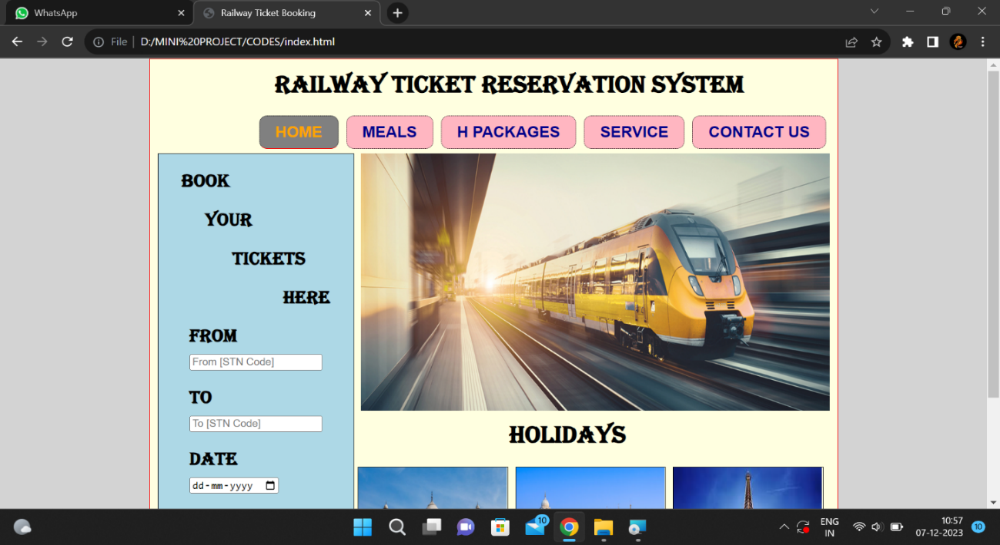

**2. MEALS**

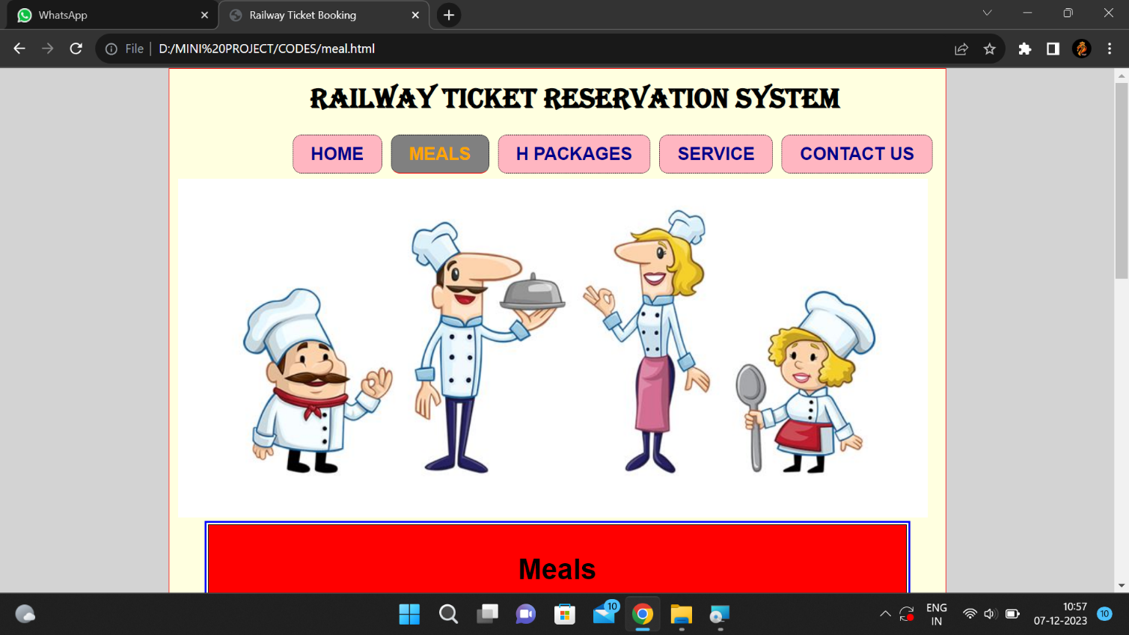

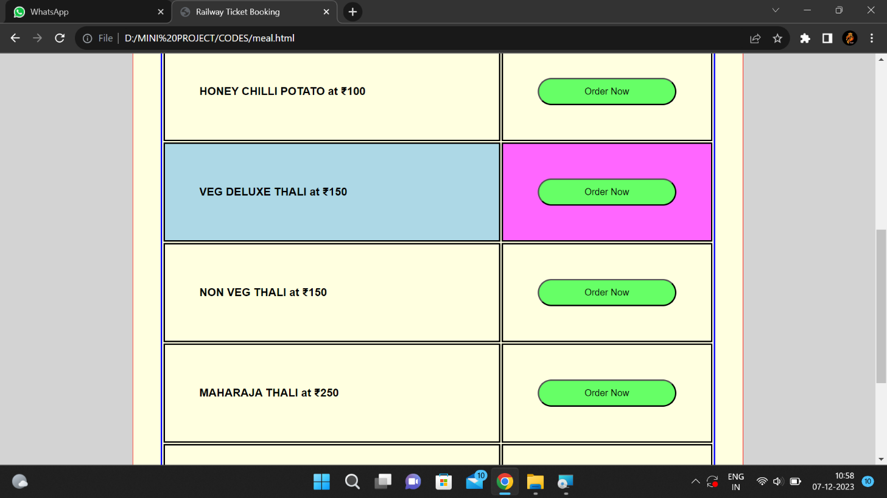

#### 3. HOLIDAY PACKAGES

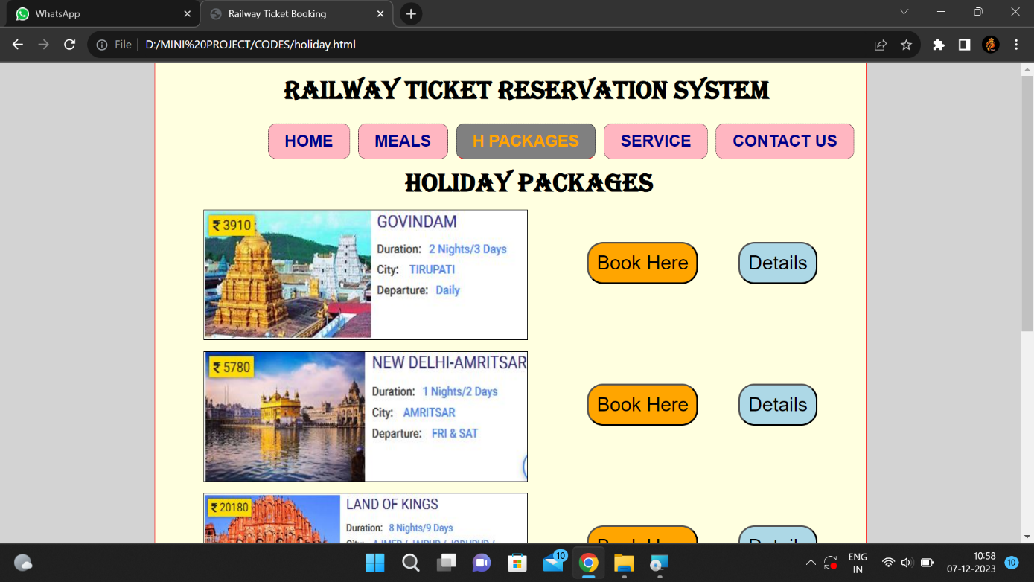

#### 4. SERVICES

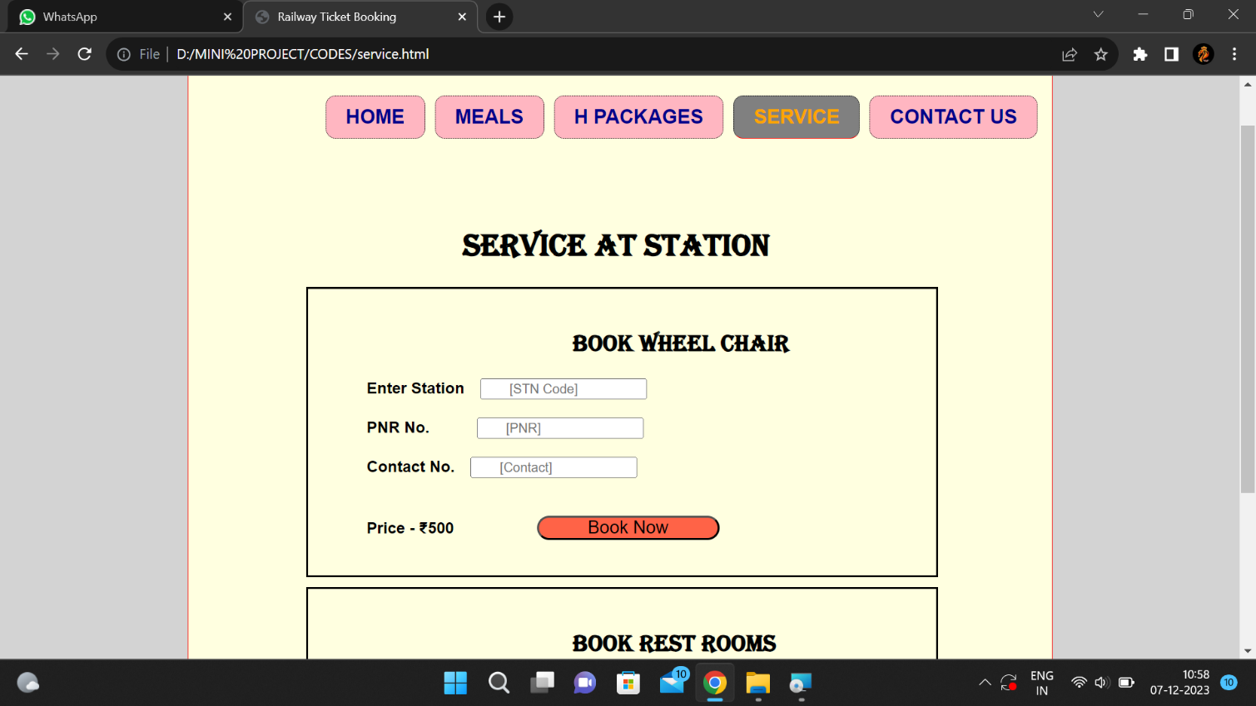

#### 5. CONTACT US

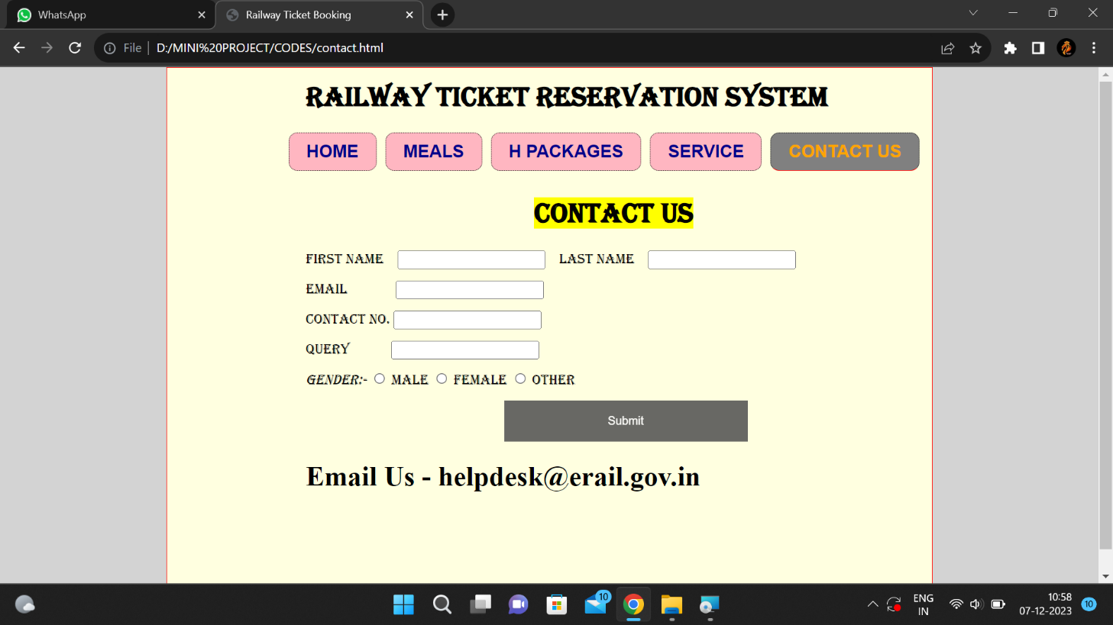

### IMPLEMENTATION CODE

### HTML

<!DOCTYPE html>

<html>

<head>

<title>Railway Ticket Booking</title>

<link rel="stylesheet" href="index.css"/>

</head>

<body>

<div class="main">

<h1 class="head">Railway Ticket reservation system</h1>

<div class="navigation"> <!--AMAN RADHE-->

<ul>

<li><a href="index.html" id="onlink">HOME</a></li>

<li><a href="meal.html">MEALS</a></li>

<li><a href="holiday.html">H PACKAGES</a></li>

<li><a href="service.html">SERVICE</a></li>

<li><a href="contact.html">CONTACT US</a></li>

</ul>

</div>

<div class="booking">

<section>

<h2 class="head1">Book</h2>

<h2 class="head2">Your</h2>

<h2 class="head3">Tickets</h2>

<h2 class="head4">Here</h2>

<form><!--AMAN RADHE-->

<ul>

<b class="fsize"> From &emsp;<input type="text" placeholder="From [STN Code]"> </b> <br> <br>

<b class="fsize"> To &emsp;<input type="text" placeholder="To [STN Code]"> </b> <br> <br>

<b class="fsize">  Date&emsp;<input type="Date" placeholder="dd-mm-yy">  </b> <br>  <br>

<label class="fsize"><strong> Class </strong> </label>

<select id="class" name="class">

<option value="select">SELECT</option>

<option value="1AC">1AC</option>

<option value="2AC">2AC</option>

<option value="3AC">3AC</option>

<option value="Sleeper">Sleeper</option>

<option value="Chair">Chair</option> <br>

</select>

</ul>

</form>

<button class="submit" type="button" onclick="trainB()">Find Trains </button>

<div class="form-popup" id="bookTrain">

<div class="popup">

<b>NAME</b> <input type="input" name="name"><br> <br>

<b>AGE</b> &nbsp;<input type="input" name="Age"><br><br>

<b>EMAIL</b><input type="input" name="Email"><br><br>

<b>MOBILE NO.</b><input type="input" name="Contact"><br>

<button type="button" class="hide" onclick="orderO()">Book</button>

<button type="button" class="hide" onclick="h1BC()">Close</button>

<h1>WE WILL SEND YOUR TICKET DETAILS ON <br> YOUR RTN IF SEATS ARE AVAILABLE.<br></h1>

<h2>THANKING YOU ENJOY YOUR JOURNEY</h2>

<h2>IF SEATS ARE UNAVAILABLE YOUR PAYMENT SHOULD BE REFUNDED</h2>

<button type="button" class="hide" onclick="trainC()">Close</button>

</div> </div>

</section>

</div><!--AMAN RADHE-->

<img class="img" src="D:\MINI PROJECT\IMAGES\home.jpg" alt="train" width="500" height="350" align="center" />

<h1 class="holiday">HOLIDAYS</h1>

<img class="imgs" src="D:\MINI PROJECT\IMAGES\taj.jpg" alt="Taj Mahal"/>

<img class="imgs" src="D:\MINI PROJECT\IMAGES\temple.jpg" alt="Golden Temple"/>

<img class="imgs" src="D:\MINI PROJECT\IMAGES\tower.jpg" alt="Eiffel Tower"/>

</div>

<script src="main.js"></script>

</body>

</html>

II.

<!DOCTYPE html>

<html>

<head>

<title>Railway Ticket Booking</title>

<link rel="stylesheet" href="index.css"/>

</head>

<body>

<!--AMAN RADHE-->

<div class="main">

<h1 class="head">Railway Ticket reservation system</h1>

<div class="navigation">

<ul>

<li><a href="index.html" >HOME</a></li>

<li><a href="meal.html"id="onlink">MEALS</a></li>

<li><a href="holiday.html">H PACKAGES</a></li>

<li><a href="service.html">SERVICE</a></li>

<li><a href="contact.html">CONTACT US</a></li>

</ul>

<!--AMAN RADHE-->

</div>

<img  src="D:\MINI PROJECT\IMAGES\meal.JPG" alt="meals" width="850px" />

<div>

<table>

<tr>

<th colspan="9"><h1>Meals</h1></th>

</tr>

<tr>

<td class="meald"> HONEY CHILLI POTATO at  ₹100 </td>

<td><button class="order" onclick="orderOpen()">Order Now</button></td>

<div class="form-popup" id="avi">

<div class="popup">

Enter PNR  <input type="input" name="PNR">

<button type="button" class="hide" onclick="orderO()">Book</button>

<button class="hide" onclick="orderClose()">Close</button>

<div class="form-popup" id="openO">

<div class="popup">

<h1>Your Meal is Booked</h1>

<button type="button" class="hide" onclick="orderC()">Close</button>

</div> </div>

</div> </div>

</tr>

<tr>

<td>VEG DELUXE THALI at  ₹150</td>

<td ><button class="order" type="button" onclick="orderOpen()">Order Now</button></td>

<div class="form-popup" id="avi">

<div class="popup">

Enter PNR  <input type="input" name="PNR">

<button type="button" class="hide" onclick="orderO()">Book</button>

<button class="hide" onclick="orderClose()">Close</button>

<div class="form-popup" id="openO">

<div class="popup">

<h1>Your Meal is Booked</h1>

<button type="button" class="hide" onclick="orderC()">Close</button>

</div> </div>

</div> </div>

</tr>

<tr>

<td >NON VEG THALI at  ₹150 </td>

<td><button class="order" type="button" onclick="orderOpen()">Order Now</button></td>

<div class="form-popup" id="avi">

<div class="popup">

Enter PNR  <input type="input" name="PNR">

<button type="button" class="hide" onclick="orderO()">Book</button>

<button class="hide" onclick="orderClose()">Close</button>

<div class="form-popup" id="openO">

<div class="popup">

<h1>Your Meal is Booked</h1>

<button type="button" class="hide" onclick="orderC()">Close</button>

</div> </div>

</div> </div>

</tr>

<tr>

<td >MAHARAJA THALI at  ₹250 </td>

<td><button class="order" type="button" onclick="orderOpen()">Order Now</button></td>

<div class="form-popup" id="avi">

<div class="popup">

Enter PNR  <input type="input" name="PNR">

<button type="button" class="hide" onclick="orderO()">Book</button>

<button class="hide" onclick="orderClose()">Close</button>

<div class="form-popup" id="openO">

<div class="popup">

<h1>Your Meal is Booked</h1>

<button type="button" class="hide" onclick="orderC()">Close</button>

</div> </div>

</div> </div>

</tr>

<tr>

<td >VEG MEDIUM THALI at  ₹150</td>

<td><button class="order" type="button" onclick="orderOpen()">Order Now</button></td>

<div class="form-popup" id="avi">

<div class="popup">

Enter PNR  <input type="input" name="PNR">

<button type="button" class="hide" onclick="orderO()">Book</button>

<button class="hide" onclick="orderClose()">Close</button>

<div class="form-popup" id="openO">

<div class="popup">

<h1>Your Meal is Booked</h1>

<button type="button" class="hide" onclick="orderC()">Close</button>

</div> </div>

</div> </div>

</tr>

<tr>

<td >NON VEG DELUXE THALI at  ₹200 </td>

<td><button class="order" type="button" onclick="orderOpen()">Order Now</button></td>

<div class="form-popup" id="avi">

<div class="popup">

Enter PNR  <input type="input" name="PNR">

<button type="button" class="hide" onclick="orderO()">Book</button>

<button class="hide" onclick="orderClose()">Close</button>

<div class="form-popup" id="openO">

<div class="popup">

<h1>Your Meal is Booked</h1>

<button type="button" class="hide" onclick="orderC()">Close</button>

</div> </div>

</div> </div>

</tr>

</table>

</div>

</div>

<script src="main.js"></script>

</body>

</html>

III.

<!DOCTYPE html>

<html>

<head>

<title>Railway Ticket Booking</title>

<link rel="stylesheet" href="index.css"/>

</head>

<!--AMAN RADHE-->

<body>

<div class="main">

<h1 class="head">Railway Ticket reservation system</h1>

<div class="navigation">

<ul>

<li><a href="index.html" >HOME</a></li>

<li><a href="meal.html">MEALS</a></li>

<li><a href="holiday.html"id="onlink">H PACKAGES</a></li>

<li><a href="service.html">SERVICE</a></li>

<li><a href="contact.html">CONTACT US</a></li>

</ul>

<!--AMAN RADHE-->

</div>

<h1 class="hpack">Holiday Packages</h1>

<div>

<img class="hpimg" src="D:\MINI PROJECT\IMAGES\hpack1.JPG" alt="hpackages"/>

<button class="bookd" type="button" onclick="h1DB()">Details</button>

<div class="form-popup" id="hBook1">

<div class="popup">

<h1>Travel to GOVINDAM</h1> <br>

<h2>3 Days Trip at TIRUPATI</h2> <br>

<h1>  Price - ₹3910</h1>

<button type="button" class="hide" onclick="h1DC()">Close</button>

</div> </div>

<button class="bookh" type="button" onclick="h1BB()">Book Here</button>

<div class="form-popup" id="hBook2">

<div class="popup"><br>

Name <input type="input" name="name"><br> <br>

Age &nbsp;<input type="input" name="Age"><br><br>

Email <input type="input" name="Email"><br><br>

Contact<input type="input" name="Contact"><br>

<button type="button" class="hide" onclick="orderO()">Book</button>

<button type="button" class="hide" onclick="h1BC()">Close</button>

<div class="form-popup" id="openO">

<div class="popup"><br>

<h1>Thanks for Booking</h1><br>

<h2>We will Contact you Shortly</h2>

<button type="button" class="hide" onclick="orderC()">Close</button>

</div> </div>

</div> </div>

</div>

<div>

<img class="hpimg" src="d:\MINI PROJECT\IMAGES\hpack2.JPG" alt="hpackages"/>

<button class="bookd" type="button" onclick="h2DB()">Details</button>

<div class="form-popup" id="hBook3">

<div class="popup">

<h1>Travel New Delhi to Amritsar</h1> <br>

<h2>2 Days Trip</h2> <br>

<h1>  Price - ₹5780</h1>

<button type="button" class="hide" onclick="h2DC()">Close</button>

</div> </div>

<button class="bookh" type="button" onclick="h2BB()">Book Here</button>

<div class="form-popup" id="hBook4">

<div class="popup"> <br>

Name <input type="input" name="name"><br> <br>

Age &nbsp;<input type="input" name="Age"><br><br>

Email <input type="input" name="Email"><br><br>

Contact<input type="input" name="Contact"><br>

<button type="button" class="hide" onclick="oO1()">Book</button>

<button type="button" class="hide" onclick="h2BC()">Close</button>

<div class="form-popup" id="o1">

<div class="popup"><br>

<h1>Thanks for Booking</h1><br>

<h2>We will Contact you Shortly</h2>

<button type="button" class="hide" onclick="oC1()">Close</button>

</div> </div>

</div> </div>

</div>

<div>

<img class="hpimg" src="D:\MINI PROJECT\IMAGES\hpack4.JPG" alt="hpackages"/>

<button class="bookd" type="button" onclick="h3DB()">Details</button>

<div class="form-popup" id="hBook5">

<div class="popup">

<h1>Travel Chennai to Shirdi</h1> <br>

<h2>4 Days Trip at Shirdi</h2> <br>

<h1>  Price - ₹3570</h1>

<button type="button" class="hide" onclick="h3DC()">Close</button>

</div> </div>

<button class="bookh" type="button"onclick="h3BB()">Book Here</button>

<div class="form-popup" id="hBook6">

<div class="popup"> <br>

Name <input type="input" name="name"><br> <br>

Age &nbsp;<input type="input" name="Age"><br><br>

Email <input type="input" name="Email"><br><br>

Contact<input type="input" name="Contact"><br>

<button type="button" class="hide" onclick="oO2()">Book</button>

<button type="button" class="hide" onclick="h3BC()">Close</button>

<div class="form-popup" id="o2">

<div class="popup"><br>

<h1>Thanks for Booking</h1><br>

<h2>We will Contact you Shortly</h2>

<button type="button" class="hide" onclick="oC2()">Close</button>

</div> </div>

</div> </div>

</div>

<div>

<img class="hpimg" src="D:\MINI PROJECT\IMAGES\hpack5.JPG" alt="hpackages"/>

<button class="bookd" type="button" onclick="h4DB()">Details</button>

<div class="form-popup" id="hBook7">

<div class="popup">

<h1>Travel to Land of Kings</h1> <br>

<h2>9 Days Trip at Rajasthan</h2> <br>

<h1>  Price - ₹20180</h1>

<button type="button" class="hide" onclick="h4DC()">Close</button>

</div> </div>

<button class="bookh" type="button" onclick="h4BB()">Book Here</button>

<div class="form-popup" id="hBook8">

<div class="popup"><br>

Name <input type="input" name="name"><br> <br>

Age &nbsp;<input type="input" name="Age"><br><br>

Email <input type="input" name="Email"><br><br>

Contact<input type="input" name="Contact"><br>

<button type="button" class="hide" onclick="oO3()">Book</button>

<button type="button" class="hide" onclick="h4BC()">Close</button>

<div class="form-popup" id="o3">

<div class="popup"><br>

<h1>Thanks for Booking</h1><br>

<h2>We will Contact you Shortly</h2>

<button type="button" class="hide" onclick="oC3()">Close</button>

</div> </div>

</div> </div>

</div>

<div>

<img class="hpimg" src="D:\MINI PROJECT\IMAGES\hpack6.JPG" alt="hpackages"/>

<button class="bookd" type="button" onclick="h5DB()">Details</button>

<div class="form-popup" id="hBook9">

<div class="popup">

<h1>Travel in Steam Express</h1> <br>

<h2>1 Days Trip at Rewari </h2> <br>

<h1>  Price - ₹3402</h1>

<button type="button" class="hide" onclick="h5DC()">Close</button>

</div> </div>

<button class="bookh" type="button" onclick="h5BB()">Book Here</button>

<div class="form-popup" id="hBook10">

<div class="popup"><br>

Name <input type="input" name="name"><br> <br>

Age &nbsp;<input type="input" name="Age"><br><br>

Email <input type="input" name="Email"><br><br>

Contact<input type="input" name="Contact"><br>

<button type="button" class="hide" onclick="oO4()">Book</button>

<button type="button" class="hide" onclick="h5BC()">Close</button>

<div class="form-popup" id="o4">

<div class="popup"><br>

<h1>Thanks for Booking</h1><br>

<h2>We will Contact you Shortly</h2>

<button type="button" class="hide" onclick="oC4()">Close</button>

</div> </div>

</div> </div>

</div>

</div>

<script src="main.js"></script>

</body>

</html>

IV.

<!DOCTYPE html>

<html>

<head>

<title>Railway Ticket Booking</title>

<link rel="stylesheet" href="index.css"/>

<!--AMAN RADHE-->

</head>

<body>

<div class="main">

<h1 class="head">Railway Ticket reservation system</h1>

<div class="navigation">

<ul><!--AMAN RADHE-->

<li><a href="index.html">HOME</a></li>

<li><a href="meal.html">MEALS</a></li>

<li><a href="holiday.html">H PACKAGES</a></li>

<li><a href="service.html" id="onlink">SERVICE</a></li>

<li><a href="contact.html">CONTACT US</a></li>

</ul>

</div>

<div>

<h1 class="service">Service at station</h1>

<div class="service2">

<h2 class="service1">Book Wheel chair </h2>

<form><!--AMAN RADHE-->

<ul>

<b>Enter Station&emsp;<input type="text" placeholder="       [STN Code]"> </b> <br> <br>

<b>PNR No.&emsp;&emsp;&emsp;<input type="text" placeholder="       [PNR]"> </b> <br> <br>

<b>Contact No.&emsp;<input type="text" placeholder="       [Contact]"> </b> <br> <br>

<b>Price -  ₹500</b>

<button class="submit" type="button" onclick="openForm()">Book Now</button>

<div class="form-popup" id="myForm">

<div class="popup">

<h1>Your Service is Booked</h1>

<h2>You will get SMS</h2>

<button type="button" class="hide" onclick="closeForm()">Close</button>

</div> </div>

</ul>

</form>

</div>

<div class="service2">

<h2 class="service1">Book Rest Rooms</h2>

<form><!--AMAN RADHE-->

<ul>

<b>Enter Station&emsp;<input type="text" placeholder="       [STN Code]"> </b> <br> <br>

<b>PNR No.&emsp;&emsp;&emsp;<input type="text" placeholder="       [PNR]"> </b> <br> <br>

<b>Contact No.&emsp;<input type="text" placeholder="       [Contact]"> </b> <br> <br>

<b>Price -  ₹1000 for 24hrs</b>

<button class="submit" type="button" onclick="openForm()">Book Now</button>

<div class="form-popup" id="myForm">

<div class="popup">

<h1>Your Service is Booked</h1>

<h2>You will get SMS</h2>

<button type="button" class="hide" onclick="closeForm()">Close</button>

</div> </div>

</ul>

</form>

</div>

</div>

</div>

<script src="main.js"></script>

</body>

</html>

V.

<!DOCTYPE html>

<html>

<head>

<title>Railway Ticket Booking</title>

<link rel="stylesheet" href="index.css"/>

</head>

<body>

<div class="main">

<h1 class="head">Railway Ticket reservation system</h1>

<div class="navigation">

<ul>

<li><a href="index.html" >HOME</a></li>

<li><a href="meal.html">MEALS</a></li>

<li><a href="holiday.html">H PACKAGES</a></li>

<li><a href="service.html">SERVICE</a></li>

<li><a href="contact.html"id="onlink">CONTACT US</a></li>

</ul><!--AMAN RADHE-->

</div>

<div class="head">

<h1><center><mark>Contact US</main></h1> </center>

<form>

First Name&emsp;<input type="text" name="First_Name" > &nbsp;&nbsp;&nbsp;Last Name&emsp;<input type="name" name="Last_Name"> <br> <pre></pre>

Email &emsp;&emsp;&nbsp;&nbsp;&nbsp;&nbsp; <input type="Email"> <br> <pre></pre>

Contact No. <input type="text" name="Contact"> <br> <pre></pre>

Query  &emsp;&emsp;&nbsp;&nbsp;&nbsp;<input type="text" name="Query"> <br> <pre></pre>

<i>Gender:-</i><!--AMAN RADHE-->

<input type="radio" name="gender" value="male"> Male

<input type="radio" name="gender" value="female"> Female

<input type="radio" name="gender" value="other"> Other <br> <pre></pre>

</form>

<pre></pre>&emsp;&emsp;&emsp;&emsp;&emsp;&emsp;&emsp;&emsp;&emsp;&emsp;&emsp;&emsp;&emsp;&emsp;

<button class="open-button" onclick="openForm()">Submit</button>

<div class="form-popup" id="myForm">

<div class="popup">

<h1>Thanks for Contacting US</h1> <br>

<h2>We will Contact You Shortly</h2>

<button type="button" class="hide" onclick="closeForm()">Close</button>

</div> </div>

<h1 style="font-family: calibiri">Email Us&nbsp;-&nbsp;helpdesk@erail.gov.in</h1>

</div><!--AMAN RADHE-->

<script src="main.js"></script>

</body>

</html>

**CSS**

body{

margin: auto;

background-color:lightgrey;

font-family: arial;

}

.navigation{

margin:auto;

width: 860px;

padding: 0px 0px 0px 130px;

height: 50px;

margin-top: 20px;

}

.navigation ul{

padding: 0;

list-style: none;;

}

.navigation ul li{

float: left;

font-size: 20px;

font-weight: bold;

margin-right:  10px;

}

.navigation ul li a{

text-decoration: none;

color: darkblue;

background:lightpink;

border-top: 1px dotted black;

border-left:1px dotted black;

border-right: 1px dotted black;

border-bottom: 1px dotted black;

padding: 10px 20px 10px 20px;

border-top-right-radius:10px;

border-top-left-radius:10px;

border-bottom-right-radius:10px;

border-bottom-left-radius:10px;

display: block;

text-align: right;

}

.navigation ul li a:hover{

text-decoration: none;

color:darkred;

background: lightgreen;

}

.navigation ul li a#onlink{

background:grey;

color: orange;

border-bottom: 1px solid red;

}

.navigation ul li a#onlink:hover{

background:white;

color: orange;

}

.main{

margin: auto;

width: 860px;

padding: 10px;

border:1px solid red;

background: lightyellow;

min-height: 600px;

}

.booking {

margin:0px;

padding:0px 100px 0px 0px;

border:1px solid black;

width: 150px;

float: left;

height: 630px;

background: lightblue;

font-size: medium;

}

.img{

width:600px;

height: 340px;

padding: 0px 0px 10px 0px;

float: right;

}

.imgs{

width: 190px;

height: 220px;

padding: 0px 1px 0px 0px;

margin-left: 5px;

border:1px solid black;

}

.head1{

margin-left:  30px;

font-family: algerian;

}

.head2{

margin-left:  60px;

font-family: algerian;

}

.head3{

margin-left:  95px;

font-family: algerian;

}

.head4{

margin-left:  160px;

font-family: algerian;

}

.submit{

margin-left: 80px;

margin-top: 20px;

padding: 0px 50px 0px 50px;

font-size:large;

background-color:tomato ;

border-radius: 20px;

text-align: center;

}

.head{

margin: 2px;

margin-left: 150px;

font-family: algerian;

}

.holiday{

margin-left: 450px;

font-family: algerian;

}

.fsize{

font-family: algerian;

font-size: x-large;

}

.hpack{

margin: 2px;

margin-left: 300px;

font-family: algerian;

}

.hpimg{

margin-top: 10px;

border:1px solid black;

margin-left: 50px;

height: 160px;

width: 400px;

}

.bookh{

float: right;

margin-right: 50px;

margin-top: 50px;

padding: 10px 10px 10px 10px;

font-size: x-large;

background-color:orange;

border-radius: 20px;

}

.bookd{

float: right;

margin-right: 50px;

margin-top: 50px;

padding: 10px 10px 10px 10px;

font-size: x-large;

background-color:lightblue;

border-radius: 20px;

}

table

{

border: 2px solid blue;

width: 800px;

margin-left: 30px;

}

th{

border: 1px solid black;

background-color: red;

font-weight: bold;

padding: 10px;

}

td{

border: 2px solid black;

font-weight: bold;

padding: 50px;

}

td:hover{

background-color: lightblue;

}

tr:hover{

background-color: #ff66ff;

}

.meald{

width: 600px;

}

.order{

padding: 10px 10px 10px 10px;

width: 200px;

background-color:#66ff66;

border-radius: 20px;

}

.service{

padding: 60px 20px 0px 20px;

margin-left: 250px;

font-family: algerian;

}

.service1{

margin-left: 250px;

font-family: algerian;

}

.service2{

border: 2px solid black;

width: 600px;

padding: 20px;

margin-bottom: 10px;

margin-left: 110px;

}

.open-button {

background-color: #555;

color: white;

padding: 16px 20px;

border: none;

cursor: pointer;

opacity: 0.89;

bottom: 23px;

right: 28px;

width: 280px;

text-align: center;

align-items: center;

}

.form-popup {

width: 100%;

height:100%;

background-color: black;

opacity: 0.96;

position: fixed;

left: 0;

bottom:0;

display: flex;

justify-content: center;

align-items:  center;

display: none;

}

.popup{

min-width: 500px;

min-height: 300px;

background-color: white;

border-radius: 8px;

text-align: center;

padding:10px 10px 10px 10px;

margin:0px 5px 0px 5px ;

}

.hide{

padding: 10px 50px 10px 50px;

background-color: orange;

text-align: center;

font-size: 20px;

border-radius: 5px;

margin-top: 80px;:

}

**JAVASCRIPT**

/* These Functions are for showing popup Windows */

function openForm() {

document.getElementById("myForm").style.display = "flex";

}

function closeForm() {

document.getElementById("myForm").style.display = "none";

}

function orderOpen(){

document.getElementById("avi").style.display = "flex";

}

function orderClose(){

document.getElementById("avi").style.display = "none";

}

function orderO(){

document.getElementById("openO").style.display = "flex";

}

function orderC(){

document.getElementById("openO").style.display = "none";

}

function oO1(){

document.getElementById("o1").style.display = "flex";

}

function oC1(){

document.getElementById("o1").style.display = "none";

}

function oO2(){

document.getElementById("o2").style.display = "flex";

}

function oC2(){

document.getElementById("o2").style.display = "none";

}

function oO3(){

document.getElementById("o3").style.display = "flex";

}

function oC3(){

document.getElementById("o3").style.display = "none";

}

function oO4(){

document.getElementById("o4").style.display = "flex";

}

function oC4(){

document.getElementById("o4").style.display = "none";

}

function trainB(){

document.getElementById("bookTrain").style.display = "flex";

}

function trainC(){

document.getElementById("bookTrain").style.display = "none";

}

function h1DB(){

document.getElementById("hBook1").style.display = "flex";

}

function h1DC(){

document.getElementById("hBook1").style.display = "none";

}

function h1BB(){

document.getElementById("hBook2").style.display = "flex";

}

function h1BC(){

document.getElementById("hBook2").style.display = "none";

}

function h2DB(){

document.getElementById("hBook3").style.display = "flex";

}

function h2DC(){

document.getElementById("hBook3").style.display = "none";

}

function h2BB(){

document.getElementById("hBook4").style.display = "flex";

}

function h2BC(){

document.getElementById("hBook4").style.display = "none";

}

function h3DB(){

document.getElementById("hBook5").style.display = "flex";

}

function h3DC(){

document.getElementById("hBook5").style.display = "none";

}

function h3BB(){

document.getElementById("hBook6").style.display = "flex";

}

function h3BC(){

document.getElementById("hBook6").style.display = "none";

}

function h4DB(){

document.getElementById("hBook7").style.display = "flex";

}

function h4DC(){

document.getElementById("hBook7").style.display = "none";

}

function h4BB(){

document.getElementById("hBook8").style.display = "flex";

}

function h4BC(){

document.getElementById("hBook8").style.display = "none";

}

function h5DB(){

document.getElementById("hBook9").style.display = "flex";

}

function h5DC(){

document.getElementById("hBook9").style.display = "none";

}

function h5BB(){

document.getElementById("hBook10").style.display = "flex";

}

function h5BC(){document.getElementById("hBook10").style.display = "none";

}

**# Appendices**

**\*\*A. System Requirements\*\***

**- *Hardware Requirements:* Minimum and recommended specifications for servers, client devices, and networking equipment.**

**- *Software Requirements:* List of software and frameworks required for the system.**

**- *Database Schema:* Entity-Relationship Diagram (ERD) or other representations.**

**\*\*B. User Documentation\*\***

**- *User Manual:* Detailed instructions on system usage, user interfaces, and common tasks.**

**- *FAQs:* Frequently Asked Questions and answers for user assistance.**

**\*\*C. Technical Documentation\*\***

**- *System Architecture:* Diagrams and explanations of the overall system architecture.**

**- *Class Diagrams:* UML class diagrams illustrating relationships and structures.**

**- *Sequence Diagrams:* UML sequence diagrams showing interaction flow.**

**\*\*D. Source Code\*\***

**- *Code Listings:* Key code snippets for critical functionalities.**

**- *Algorithms:* Detailed explanations of complex algorithms used.**

**\*\*E. Testing Documentation\*\***

**- *Test Cases:* Detailed test cases for modules or functionalities.**

**- *Test Results:* Summary of test results, including issues and resolutions.**

**\*\*F. Project Timeline\*\***

**- *Gantt Chart:* Visual representation of project timeline, milestones, and deadlines.**

**\*\*G. Stakeholder Communication\*\***

**- *Communication Plan:* Outline for stakeholder communication during development and implementation.**

#### REFERENCE

### SELF

### 2. CODE WITH HARRY

### 3. YOUTUBE

### 4. SENIORS